*Z.H.C.E.T., Aligarh Muslim University – Aligarh*

**Network & Embedded Systems Lab**

(COC **4950**)

**REPORT**

**Objective:** Design and simulate a 5-bit Majority Circuit.

Submitted by: **Ravi Sahni**

Faculty No.: **17 COB 085**

Enrolment No.: **GJ 7718**

**Simulation Environment:** ModelSim PE Student Edition 10.4a

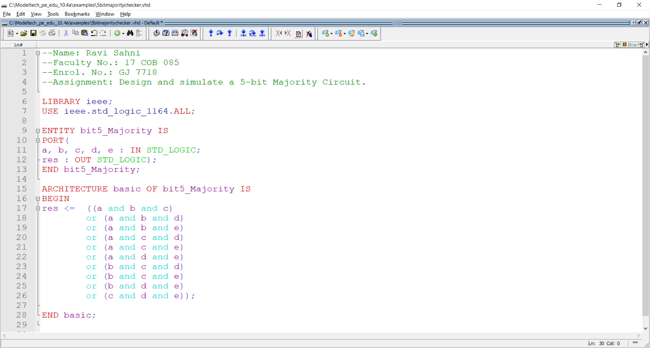**VHDL Code:**

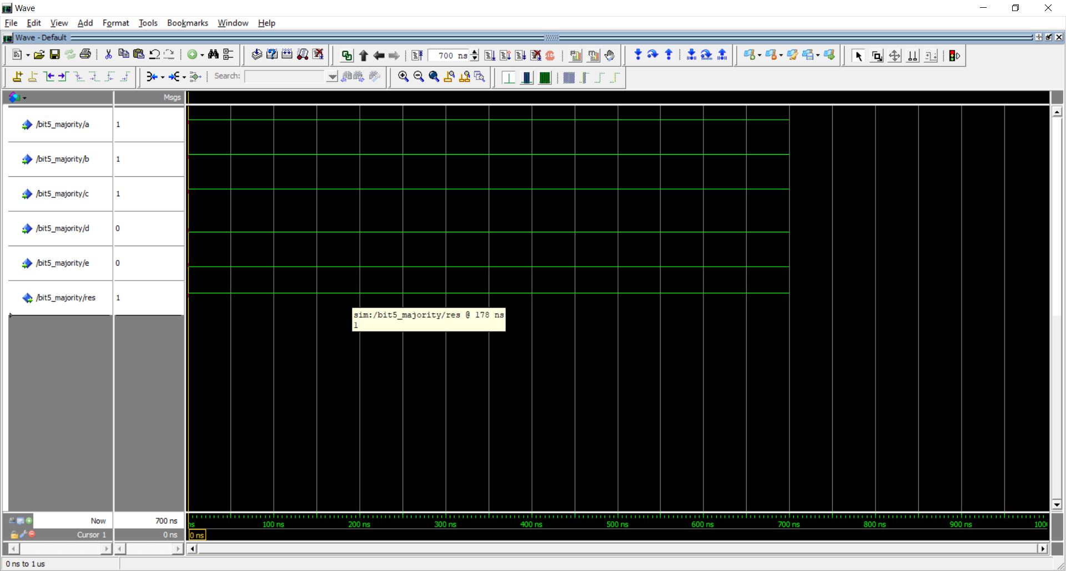**Waveform #1:**

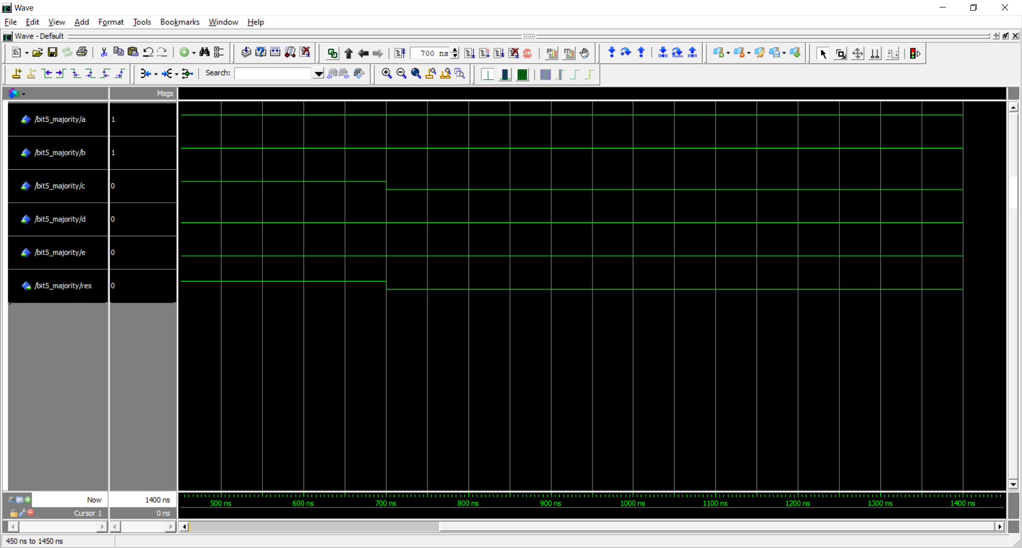**Waveform #2:**